Before:
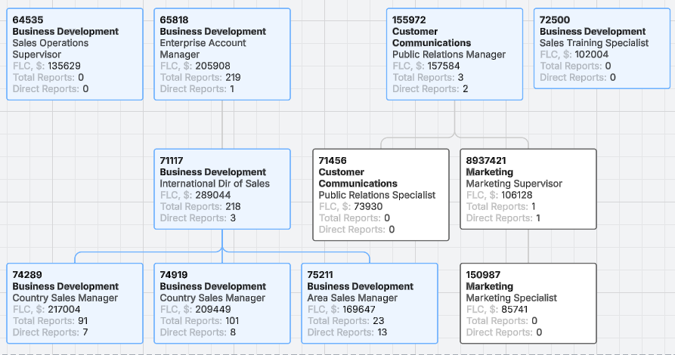
After making changes to org chart: moved 72500, 155972 and 64535 under 65818
